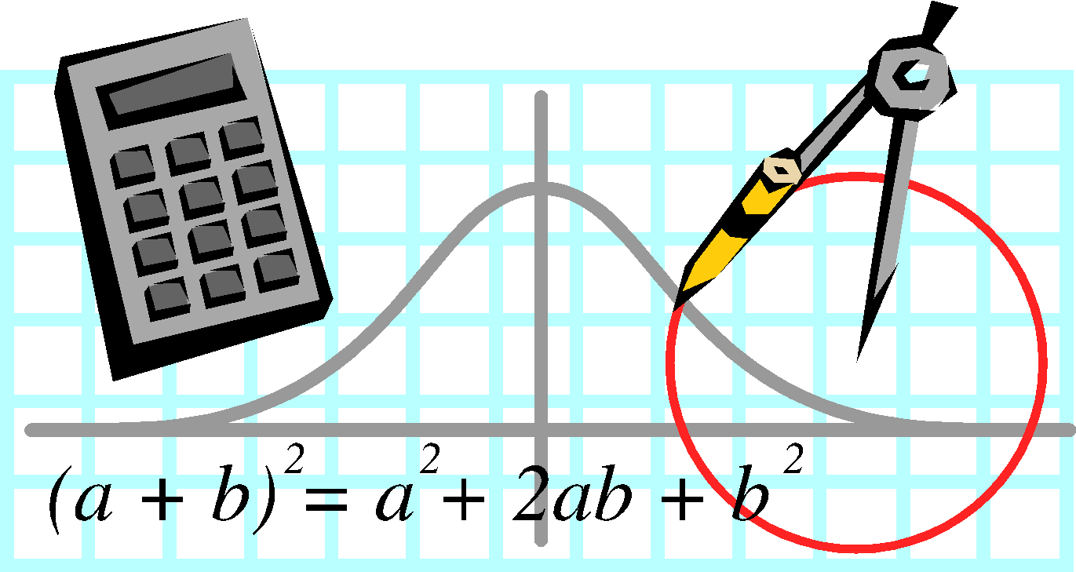
Syllabus and Classroom Management Plan for:
8th Grade Math

Name: Mark Huey
Email: fhuey@chester.k12.sc.us
Phone: (803) 385-6334 ext. 626

Introduction: Welcome to 8th grade Math!! I am excited to be your teacher! This will be my second year as middle school math instructor. I taught middle school social studies for two years and fifth grade math and social studies for eleven years (2004-2016.) I am looking forward to this 2019-20 school year where I return to teaching math full time. I have degrees from Erskine College and Winthrop University and a Master’s Degree from Columbia College. My hobbies are dirt track racing, playing the piano, and spending time with family and friends.
Course Description: The Eighth Grade South Carolina College and Career Ready Standards are organized under five areas of study—The Number System, Ratios and Proportional Relationships, Expressions Equations and Inequalities, Geometry and Measurement, and Data Analysis/Statistics. Over the course of the year, each student will:
- Make sense of problems and persevere in solving them.
- Reason contextually and abstractly.
- Use critical thinking skills to justify mathematical reasoning and critique the reasoning of others.
- Connect mathematical ideas and real-world situations through modeling.
- Use a variety of mathematical tools effectively and strategically.
- Communicate mathematically and approach mathematical situations with precision.
- Identify and utilize structure and patters.
Textbook: Carnegie Learning Math Series Course 3

Course Outline (Pacing Guide):
Concepts/Standards | Time Length
Transformational Geometry: 8.GM.1,2,3,4,5 | 4 Weeks
Exponents: 8.NS.1,2,3, - 8.EEI.1,2,3,4,7a, 7b – 8.DSP.5 | 4 Weeks
Algebraic Geometry: 8.GM.6,7,8,9 – 8.EEI.2 | 5 Weeks
Functions: 8.F.1,2 | 5 Weeks
Linear Functions: 8.EEI.5, 6 – 8.F.3, 4, 5 | 5 Weeks
Statistics with Linear Models: 8.DSP.1, 2, 3, 4 – 8.F.3,4,5 | 5 Weeks
Systems of Equations: 8.EEI.7,8 | 4 Weeks
Final Benchmark, SCREADY, Comprehensive Review of SCCCR Standards | 2 Weeks
End of Academic Year Independent Research Project (after SCREADY testing is complete) | 3 Weeks

Objectives from SC Math Standards: All units are based on the state standards. For more information about the SC College- and Career-Ready Standards, please visit the website https://ed.sc.gov/instruction/standards-learning/mathematics/standards/

Required Materials: Students will need a spiral notebook or composition book to use for math only. Students will complete math assignments and take class notes in their math notebook each day. We keep these in class unless they would like to take them home to help them study.

Agenda: Students are given an agenda the first week of school and they are required to write their homework assignments and any upcoming quizzes or tests daily. They should have something written under math every day in their agenda. I also use the agenda to write notes to parents.

Grading Policy: 10-Point Uniform Grading Scale Approved by State Board of Education

Grading Scale:
A 100-90
B 89-80
C 79-70
D 69-60
F 59 or below

Grades will be based on the following:
Summative Assessments (Tests, Projects) – 40%
Formative Assessments – 60%
- Quizzes & Classwork
- Independent Practice
- Vocabulary/Homework
- Daily Progress & Accountability (Materials & Ready to Learn/Daily Participation)

MAP TESTING (Fall, Winter, Spring)

You will be taking the MAP (Measures of Academic Progress) tests three times during the school year. Data is used to determine strengths and weaknesses identified by which objectives you answer correctly and incorrectly. You will be held accountable for your time spent on these tests. I will receive an “Accountability” grade for each test and time spent on task (as calculated by the computer software) will determine your grade. You will need to work hard to achieve your goal on these tests, as points scored over your goal will be credited as bonus points/extra credit at the end of the grading term.

Homework: Students will be given a homework page every Monday. All assignments are planned in accordance with the instruction from that class session. I do not advise students attempt to complete the entire week of homework in one night. All homework assignments will be turned in on Friday and will be graded as an independent practice grade.

Quizzes: A quiz will be given after a new skill is taught and reviewed. Study guides are also given to help students prepare for quizzes. I do not give pop quizzes and students are always notified in advance if they have an upcoming quiz.

Tests: Will be given at the end of each unit. I will give students a study guide and ample notice before a test .

Projects: Will be assigned accordingly with advance notice.

Classroom Rules:
- Follow all rules and regulations of the ATL Middle School.
- Come to class on time, prepared and ready to learn.
- In everything we do, respect your teacher, yourself, others, and their property.
- Give your best effort at all times.
- All students are to remain in their seats unless given permission.

General Procedures:
- Class Starter/Warm-Up questions
- Instruction
- Guided or Independent Practice
- Conclusion
Consequences:
- Student will be warned about their behavior.
- Student will be receive silent or working lunch detention.
- Parent will be called.
- Student will receive a referral and sent to the principal.

INSTRUCTIONAL ROUTINES: (for parents)
Students log in to their accounts on laptops.

Each lesson will be intentionally taught within the context of a South Carolina College-and-Career Readiness Standard indicator. These standards are used pinpoint the skills required to complete academic tasks, such as those your child are expected to show mastery on the SCREADY and MAP tests administered annually. Test results from previous years will be used to determine readiness levels and will help guide instructional decisions for your child.

This class will not be taught from the standpoint of “whole-group” instruction. Each lesson will be specifically tailored to meet the needs of your child.

Each student will be using technology every day in this math class, as it will be taught via the computer. They will need to maintain a school email address (you should have one from computer lab). Individual and one-to-one instruction will take place daily as needed. They will also work periodically in their Carnegie workbooks.

My lessons will all follow the same format daily, with tech-based instruction and assessments using these and others databases. You will have accounts to access all of these sites daily.

Khan Academy (www.khanacademy.org)
Learn Zillion (www.learnzillion.com)
Virtual Nerd (www.virtualnerd.com)
IXL (www.ixl.com)

**I am very excited about this upcoming year! We are going to work very hard, have a lot of fun, and work together as a team to make this a fantastic and successful year!
-Mr. Mark Huey

